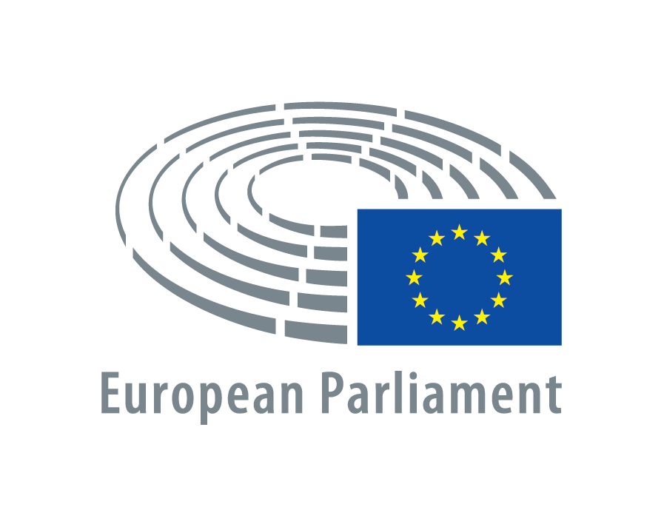
Date:

Written Declaration 0015/2016

on Universal access to maternal healthcare

I hereby support the Written Declaration

Name of Member (typed or capital letters) Signature

OR

I hereby withdraw my signature to the Written Declaration

Name of Member (typed or capital letters) Signature

Signature only accepted when sent from Member's own mailbox to:

WritDeclSign@europarl.europa.eu

